MDWG, Monday 23 March 2020

Note: The 6th meeting of the ANZLIC/ICSM Metadata Working Group was held in a virtual meeting space using ZOOM due to travel restrictions imposed by the COVID-19 pandemic.

Attendees: Irina Bastrakova, Byron Cochrane, Melanie Barlow, Leila Hernandez, Michael Rigby, Brenda Lilley, Shanti Rowlison, Kate Roberts, Chris Body, Katherine Tattersall, Simon Cox, Natalia Atkins, Dave Connell, Jenny Mahuika, David Drynan, Nichola Burton, Mingfang Wu, Aaron Sedgmen, Joel Haasdyk, Jason Murray, Graham Logan, Jenny Smith, Anthony Eastcott

Chair: Irina Bastrakova
Secretariat: Jenny Long

All action items from the meeting were distributed separately and are available at https://www.icsm.gov.au/sites/default/files/Action%20Items%20from%20the%20ANZLIC%20MDWG%20meetings.xlsx

AGENDA ITEM | KEY POINTS
INTRODUCTION
Welcome Address  (Craig Sandy) | Craig Sandy, the Surveyor-General of Victoria, provided a welcome address to the meeting.  Key points raised:  - ICSM recognises the importance of metadata and standards in providing dataset products and services of geospatial information  - ICSM will be supporting a modernised spatial data framework which includes 14 themes determined by UN-GGIM (Fundamental Geospatial Data Themes); both the individual themes and how they interact are important  - Metadata and standards vital in sharing information in new and expanding knowledge areas, such as Digital Twins and other collaborative platforms  - There is an expanding reliance on machine readable data to utilise machine learning  - MDWG focus needs to change over the next 6-12 months increasing collaboration with other ICSM working groups. Each working group will need to incorporate a metadata and standards focus. MDWG expertise will be required; without it there is potential for non-compliance with standards through "easier" solutions  - FAIR principles are fundamental, as is the need for it to be easy for people to create and understand metadata  - Use current situation of COVID-19 to highlight the importance of our work. This is a spatial problem, and we have an opportunity to provide products, services and tools to help; requires quality, accurate, reliable data to enable government to make good decisions
Meeting #5 Outcomes  (Irina Bastrakova) | Irina Bastrakova started the meeting by introducing the meeting agenda, expected outcomes, review of outcomes of the previous meeting and action items (see slide presentation link).  The agenda for the meeting was outlined and the following meeting expectations were noted:  - members will be better informed about activities and practices in communities related to metadata  - the MDWG Roadmap v1 will be reviewed and discussion will commence regarding the development of a new version of the Roadmap incorporating recognition the MDWG will work more closely with other ICSM working groups in the future to highlight the importance of metadata and help standardise metadata practices  - Importance of publishing geography and built environment vocabularies  - Greater understanding of GDA2002 challenges and transitioning to it  Review of the Action Items showed that most of them were completed. Several items were on hold and needed to be confirmed through development of the Roadmap v2. Items in progress were reconfirmed by the Meeting attendees and agreed to be included to the Roadmap v2.  The Technical Metadata Working Group meet fortnightly online and are very active in discussions and achieving outcomes of Roadmap v1 and action items.  Irina commented on the increased attendance at MDWG Meeting #5 (October 2019) and noted the following outcomes from the meeting:  - Highest attendance since MDWG formed (and increased membership since the October meeting)  - Comprehensive discussion around GDA2020  - Review of options for structured and machine readable metadata at attribute level metadata (data dictionaries)  Overall, positive feedback from ANZLIC and ICSM, interest in participation and progress in achieving Roadmap v1 outcomes clearly indicates importance of MDWG and what we are doing for the Australian community in general
INTERNATIONAL AND NATIONAL COMMITTEE UPDATES
ISO/OGC Update  (Chris Body) | Chris Body provided an update on activities re ISO/OGC standards (see slide presentation link).  ISO/TC211  - Personnel changes for ISO/TC211 as participants who have been active for years transition to retirement  - Geospatial information is required across multiple business sectors; ISO model struggling to integrate across sectors (horizontal requirements for particular standards, particularly geospatial) - made more difficult by challenge of sourcing funding outside core business  - Update provided on the current status of work by various ISO/TC211 Working Groups (see slides). Of note:  - WG6 Imagery: moving away from an international standard to technical specifications based on feedback from various member countries that international standards document is too restrictive/structured  - WG7 Information Communities (bulk of vocabulary and ontology work) :  > increased implementation of these standards internationally - feedback received about - will see amendments in future  > Change of thinking moving away from XML towards Linked Data/ontologies/vocabularies  - WG10 Ubiquitous Public Access: technical specification on BIM and GIS expected July 2021  - Landcover/Landuse update to support UN's Sustainable Development Goals  - See https://committee.iso.org/sites/tc211/home/projects.html for full list ISO/TC211 activities  OGC  - Key OGC contacts for Australia/New Zealand now Chris Body and Rob Atkinson  - Testbed 16 - Thread 2 (Data Integration) & Thread 3 (Modelling and Packaging) may be of interest  - Callout for API - Features - Part 2 Coordinate Reference Systems by Reference (April 2020)  UN-GGIM  - OGC, ISO/TC211 & IHO work in framework of UN-GGIM  - Contributed to Integrated Geospatial Information Framework  - Developed Guide to the Roles of Standards in Geospatial Information Management; endorsed and being published twice  - Supporting various UN-GGIM work programs (see list in slides)  In discussion it was noted that a considerable effort is required to migrate to a standard once published, and there may be an issue with progressing such a large number of standards into the implementation community once the development has been finalised. The focus on standards at the recent ICSM meeting was alluded to again; this focus may help raise the importance of standards compliance.  It was also noted, that ICSM MDWG is the global leader in promoting and adopting the ISO 19115-1 standard and can provide a valuable advice on its implementations. The MDWG should become more active in participation in ISO/OGC activities
W3C Update  (Simon Cox) | Simon Cox reported on the current status of W3C activities (presentation available at link).  The following points were noted:  DCAT v2:  - The DCAT data catalogue vocabulary (an RDF vocabulary) is a list of metadata records describing datasets, their representations and the relationship between them  - DCAT v2 was made a Recommendation (equivalent of a standard) by W3C on 4 February 2020  - DCAT v2 has been upgraded to support the standard paradigm of how geospatial services would need to be described in the catalogue  - Differences between DACT v1 (2014) and v2 (2020):  - extended to accommodate catalogues of data services  - number of temporal and spatial properties of resources expanded, allowing greater definition (5 distinct temporal properties and 2 spatial properties)  - improvements to the ability to describe the relationship of datasets/services to other datasets, including the addition of a generic relationship which can have a user-defined role attached  - expanded set of role attributions (eg. "custodian")  OWL time ontology:  - Allows the description of relationships between temporal entities; set of relationships similar to spatial relationships (intersection, touching, overlaps, etc.)  - Feedback from user: No way to assert that two time-instants are equal (coincident) - led to examination of completeness of temporal relations and found a number of issues. Four new relationships now published as a draft extension to address these issues  - Current/unfinished work on temporal aggregates are described in document  Irina queried publication of a vocabulary for temporal reference systems (eg. Gregorian time). Simon believes this is on the agenda for the Temporal Domain Working Group in OGC (Chris Little).  Byron asked about implementations, in particular the relation of DCAT with OGC API Records. Simon advised after some reluctance from them it seems there's a standard record format which maps almost exactly to DCAT. Byron noted the difference between allowed queriables, the interface, and the standard behind it, and believes it would be useful if we could have DCAT format behind it rather than geoJSON. Simon provided the following link for reference: https://github.com/opengeospatial/ogcapi-records/issues/25.
Communities of Practice Updates  (Mingfang Wu, Melanie Barlow) | Mingfang Wu provided a brief introduction to the ARDC Data Quality Interest Group (see presentation available at link).  The DQIG was formed in October 2019 to discuss challenges and strategies for meeting data quality standards and procedures. Ming is facilitator for the group, which meets every 2 months online. All involved in data are welcome to join - email Ming if interested. https://docs.google.com/document/d/1Yt7WyAiWsFRaaMvFXffcCnWPKw58MVSoULN0Cm1PR5I/edit  ESIP data quality information cluster wiki has further resources on data quality: http://wiki.esipfed.org/index.php/Information_Quality  Some current aims for the group:  - Collecting data strategies from organisations within Australia, to help create general guidelines for development of data quality strategies  - Organising a one day workshop on data quality with input from Lesley Wyborn (representing the Australian Data Quality Interest Group) and Ivana Ivanova (representing the OGC Data Quality Working Group). This workshop is likely to go online  Irina noted the importance of data quality for accurate metadata and hence the importance of the Data Quality Interest Group. Previous discussions by MDWG on ISO 19157 (Data Quality Standard) to see what elements we would need to use. This work is also quite important as it relates not just to data quality but also ancillary data and the Australian Datum. Suggested we build closer connections with this Community of Practice, as well as the work that Ivana Ivanova is doing on ISO 19157  Melanie Barlow was then called on to provide an impromptu overview of the ARDC Geospatial Capabilities Community of Practice.  The Group started late last year and is still working out overlaps and communications with other Communities of Practice and are hoping to gain momentum soon. There are currently 4 Chairs and the Group welcome new participants and ideas; see https://sites.google.com/ardc.edu.au/geospatialcapcop for information on how to join. The website also includes information about past and future meetings, links to presentations, as well as a spreadsheet of presentations and resources for construction the group would like to progress in the future. Information for joining the related Google Community Space is also available from the website.  Irina noted that this is an extensive group, with over 80 participants at the first meeting from a wide spectrum of backgrounds (federal and state government agencies, universities and industry), and as such is a good resource for collecting opinions and/or use cases.
TECHNICAL WORKING GROUP UPDATES
Survey results: Metadata for Imagery; Metadata for Digital Data Preservation  (Irina Bastrakova) | Irina Bastrakova outlined how the proposed workshops from MDWG#5 (October 2019) around the need to create metadata profiles for imagery and collection, and digital data preservation, became two high-level surveys of stakeholders. The surveys were designed to gain insights into the metadata environment and landscape within Australia, to gauge user's understanding of existing profiles, and clarify what is being done in this space. From the results of the survey the aim was to concentrate on more detailed use cases and potentially develop individual profiles for different datasets as required.  Irina's slideshow presentation of the results of the surveys is available at link  Metadata for Imagery and Data Acquisition  The survey result showed that organisations consistently collect ancillary data and usually provide it with product specifications. However, this information is not always publically available to external users through metadata and required additional requests for downloads or media transfers. A consistent requirement for developing ‘simple’ structured metadata was defined through the survey  Proposed next steps:  - Need to build collaboration with ICSM Imagery and Elevation Working Group to identify requirements  - Analyse requirements and develop crosswalks between ISO 19115-1 and ISO 19115-2 & other standards as required  - Inform ISO TC211 of our work and provide feedback to them as required  - Present findings and propose new profile (as a best practice guide) at next ICSM MDWG meeting if progressed  Metadata for Digital Data Preservation  Responding organisations indicated that they consistently archive data and services, and maintain data access through updated formats. The survey showed a certain level of uncertainty in understanding compliancy requirements when preserving data. The survey also showed a low level of archiving associated data/services specifications and standards which may create difficulties in their understanding in the future. Understanding of archiving policies is important to improve organisation’s ability to access and re-use data in the future (eg. DC2020 for federal agencies)  Proposed next steps:  - Build better relationship with NAA and raise awareness on MDWG requirements  - Identify the policies, regulations and standards of relevant jurisdictional agencies  - Analyse those policies/regulations and create crosswalks between standards  - Present at next ICSM MDWG meeting  Discussions following the presentation:  - Irina clarified not intention to develop new standards but to take existing standards and develop best practice recommendations around how they can be applied to ensure interoperability and simplified access to data for different use cases. Once we start this work it will become clearer whether there are gaps between 19115-1 and 19115-2, and whether there are aspects of a use case's community that simply cannot be adapted to the standard.  - Shane Crossman (the Deputy Chair of the ICSM Imagery & Elevation Working Group (IEWG)) joined the meeting briefly to give an overview of IEWG's aims. Their theme of "imagery" covers elevation, depth and imagery (everything from Lidar to bathymetry to satellite imagery). Members of this group are very technical in how they go about acquiring data, but don't have much experience in metadata; they know they need to capture a number of elements to meet their acquisition requirements, but don't know where that fits within metadata standards. Initially asked to define those elements that are currently present/missing from their specifications for acquisition, and will then ask the MDWG where those elements fit within the standards for metadata. This should help to build the crosswalks referred to above.  - Shanti Rowlison noted Defence use the US motion imagery standards as a default, and that she has done an initial assessment of the differences between this standard and ISO 19115. Irina asked if she could share this with the group.  - It was observed that users should not be required to have an understanding of standards, but should interact with well-built tools which guide them appropriately. We need an understanding of what elements are currently being collected and compare that with what is required by the standards to be able to identify any potential gaps, which should improve collection of metadata. A further issue lies in fact the same element can be represented in multiple ways; to bring them to a common denominator in a structured way is not easy. There is a requirement for people who can understand both metadata and the actual data to help define gaps and aid in the building of suitable tools.  - It was asked if we have anyone representing an emergency services or natural disasters perspective - Irina noted EMSINA committee member at Geoscience Australia (Kane Orr)
GDA2020 Update  (Joel Haasdyk) | Joel Haasdyk provided an update on GDA2020 (slides available link)  Key points from the presentation:  - Working towards ANZLIC 30 June 2020 deadline for finalising an update to the standard  - ISO 19115-1: updates pending, to require coordinate reference system and to require coordinate epoch where coordinate reference system is dynamic. Amendment timeframes likely to be longer than usual  - Australia is planning to submit new EPSG codes to reflect this which will exist alongside existing codes rather than replacing them, requiring education on correct usage  - GMIWG intend to put out new Fact Sheets, particularly looking at changes to WGS84/time-dependence/EPS. In addition they intend to produce metadata fact sheets outlining how to properly use metadata. This unofficially provides an opportunity for the MDWG to provide information on:  - ISO 19139 to 19115-3 updates  - examples for users on how to indicate lineage, e.g. source data => transformation => storage datum  - recording differentiation between GDA2020 compliant and GDA2020 compatible  - potential updated ANZLIC Metadata Tool  In addition, it was noted Australian standard 5488 (Underground Utilities) doesn't currently define datum, despite being reviewed in 2018 - looking to have this included  There was discussion around whether existing metadata parameters for coordinate epoch are sufficient to move forward with, while perhaps pushing for a larger review. It was suggested that data epoch be recommended for any coordinate reference system. There were concerns that the amendments proposed for the ISO 19115-1 do not meet requirements to capture all the necessary epoch information from acquisition through to end product and all the processing in between; concern is that processing information is hidden within a text field and is therefore not easy to find. This leads to issues re accuracy which may not be acceptable in some domains (defence, utilities, logistics, etc). There is a need to define and communicate exactly what each metadata item means so that information is entered correctly and to reduce confusion. Current definitions appear in different standards (e.g. unclear where observation epoch is defined, while most other epoch definitions are within ISO 19111, and not within the ISO 19115 update). It was agreed that in 19115-2 process steps should include elements that cater for epochs.  Rather than extend discussion around these issues it was suggested to organise a Google document where issues can be recorded, allowing for a record of items to be addressed and solutions as they are found. At the last meeting a structure description for transformation for different epochs in the process step class under lineage was discussed - Byron was asked to look into this. It was also agreed to dedicate the next Technical Metadata Working Group meeting on 3 April to this issue, considering its urgency. Zarina and Joel Haasdyk to be included in meeting invite.
Metadata for Services  (Melanie Barlow/Aaron Sedgmen) | Melanie Barlow provided a presentation (link) in which she discussed an overview of 3 spreadsheets which were developed to describe aspects of Metadata for Services. Spreadsheets are available at link:  - 19115-1 Service - Recommended Elements: mapping to various elements for creating a Service Metadata record  - 19115-3 Example Dataset Metadata - Related Service: concept of dataset metadata and what service information might be available within  - 19115-3 Example Service Metadata - Related Dataset: example of service metadata record and how it might link back to the related dataset  Ultimately the content outlined in the spreadsheets will be used to construct the Best Practice Guide for Service Metadata. Content is open for discussion/feedback, including level of granularity required. It was noted the spreadsheets only include wms at this stage, but intention is to expand for wfs, sos, etc.  Following Melanie's presentation it was observed that OGC Catalogue Service 3.0 and OGC API have been rolled together (now OGC API Records) - Byron Cochrane to send Melanie link for queriables for OGC API Records. Melanie also noted she would need to factor in levels of adoption of DCAT v2.  Aaron Sedgmen presented on an aspect of Service Metadata which Geoscience Australia has found to be a challenge - how to link to services from a dataset metadata record where the service has multiple layers, in this case where the data is accessed via web services. Problem with current usage pattern is there is no strict association between the dataset metadata record and the layers in the web service, instead it relies on having an intuitive match between the layer name and the dataset name.  GA has identified two possible solutions:  - To use a protocol in URL in the dataset metadata record that is specific to the layer, e.g. for a WMS could use the GetMap protocol, but this requires customisation to get it to work each time  - To use the "Name" field in the "OnlineResource" element of the distribution information to contain the actual layer name, but this introduces a convention which is outside the standard. Issue is that other applications (such as QGIS) would not necessarily know that the layer is recorded in the "Name" field, as that was not intended use - has been developed as a human workaround and is not machine-readable.  Byron noted the issue around the use of the "Name" field to record layer name is being considered by OGC API Records and offered to forward the conversation thread for information to see if it is worth following up on this matter.  Aaron noted neither of these solutions is ideal; it would be preferable if the distribution information section of ISO 19115-1 was able to handle layer level information pertaining to spatial data services.  Melanie requested Aaron provide her with further information around the issues to allow further conversations around what recommendations/requests might be made to ISO.
Communication and Promotion  (Irina Bastrakova) | Irina Bastrakova outlined a need for further development of MDWG's promotion and communications strategy (presentation slides available at link)  The following promotional materials were noted as already available or in progress:  - Reports to ICSM and ANZLIC on MDWG progress, forward planning and requests for funding or identified risks  - The website has links to a number of presentations which can be accessed for reference and/or for reuse by members of the Group  - The metadata animated video  - A paragraph about the MDWG was recently published in the national eResearch newsletter; it was noted we could use similar outlets for promotional purposes  - Reference materials:  - Register for Metadata Tools and Resources  - Register for Metadata Resources for Users  - Metadata Best Practice User Guide  - Security Classifications  - Surveys and their results  - Links to vocabularies and code lists  Most of this material is available from the MDWG website, providing a centralised portal for the wider community access. Irina suggested a review of the current website, considering both content and structure, and ensuring it aligns with ANZLIC/ICSM websites with direct links. Feedback on the current website was requested from MDWG members.  Suggested new material:  - Factsheet around why certain standards apply  - Factsheet around GDA2020 and how to use it  - Links to further presentations (perhaps from other members) which could be made accessible from the website  During discussions it was asked what level the current material is addressed towards, and particularly whether any of the existing materials are appropriate for senior management. It was observed we may have a potential gap, as there seems to be a trend from management to push to get the data out, rather than committing to the effort required to migrate to new standards and/or to ensure appropriate levels of metadata are recorded, particularly at the state level. Is it appropriate for us to be trying to drive change from the bottom-up, or should we aim to engender support from higher levels of organisations as there is considerable effort involved to implement the changes we are suggesting? Issues exist around allocation of resources and general misconceptions around metadata and the effort required to implement it appropriately. Is it our role to influence at a management level, or is this the role of ANZLIC/ICSM? It was agreed that these considerations need to be factored in when workshopping the Roadmap tomorrow.
Technical Documentation: A Framework for Production of Useful Guidance Material in four parts  (Byron Cochrane) | Byron Cochrane outlined an approach to technical documentation recognising four different styles of documentation for different user groups, which should be cross-referenced. It was suggested the MDWG consider to use for any shortfalls in the current documentation (presentation slides available at link).  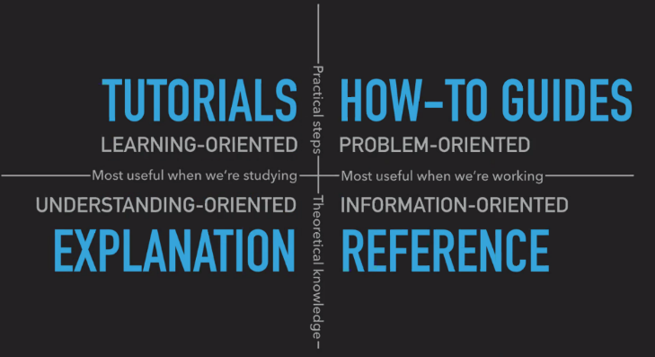  TUTORIALS  Lessons that take the reader by the hand through a series of steps to complete a project  Learn by doing, eg. building confidence in the kitchen through cooking with beginner  HOW-TO GUIDES  Guides that take the reader through the steps required to solve a common problem  Series of steps; addressing a specific question; practical usability, etc. E.g. Cook books  REFERENCE  Technical descriptions of the machinery and its operation  Authoritative and normative, but doesn't tell you how to do something (structure, consistency, description, accuracy)  EXPLANATION  Discussions that clarify and illuminate a particular topic  (giving context, explaining why, multiple examples, alternative approaches, making connections, no instruction or technical description)
NATIONAL POLICIES AND REGULATION
National Archives of Australia: Next steps after DC2020  (Irina Bastrakova for Esther Carey) | Irina Bastrakova presented slides provided by Esther Carey from National Archives Australia - refer to slides at link.  The NAA are planning to implement a new information policy post DC2020, and are seeking feedback: what are current metadata challenges for Australian Government, and how can they be addressed?  Following the presentation it was noted that NAA have not yet addressed questions regarding ISO from our last meeting, due to various delays. There is a lack of clarity around who is responsible for providing a reply.
METADATA IMPLIMENTATION EXAMPLES
Vocabularies and Data Integration  (Jenny Mahuika) | Jenny Mahuika from TERN provided information relating to controlled vocabularies and data integration (see link).  TERN faces the challenge of harmonising diverse datasets incorporating a combination of various human and sensor observations at different spatial and temporal extents in multiple formats (point, grid, etc.) and scales (regional/national). A recent objective has been to combine data from different sources into usable and trusted information, then present and provide ability to synthesise those datasets. Controlled vocabularies provide an opportunity to harmonise data at different scales and across different domains, at a general and specific level. Various examples of the complexities to be considered when looking to integrate diverse datasets were given.  A brief overview of the process undertaken by TERN:  - Identifying specific domains/categories within a dataset (ontology)  - Analysing whether an existing vocabulary will meet end-use needs or whether a new vocabulary needs to be built  - Determining configuration - standard(s), properties, deployment of a vocabulary management user interface, and defining vocabulary storage  - Developing vocabulary items: label, abstract/definition, authoritative source reference, date created, etc.  - Configuring deployment (embedded into data selection tool, and potentially made available in a vocabulary viewer)  - Managing data submission process (reviewing submissions, checking data quality, etc.).  Tools developed for this process include a Vocabulary Indexing tool (for very large vocabularies), and a Data Submission Tool.  In discussion it was asked whether the new vocabularies created would be published in RVA. Jenny advised she would need to confirm, but felt that the vocabularies developed are specific to TERN's domain so may not be of interest to other users, and also may not be compatible with RVA standard.  For further information on the current status of this work visit the websites below.  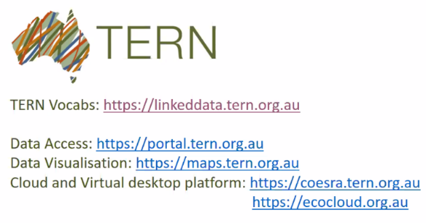  Following the presentation Irina asked whether there was a demand for a specific workshop around vocabularies; interested members were asked to let Irina know for potential inclusion in the agenda for the next MDWG meeting in July.
IMOS Marine Community Profile - transition to ISO 19115-3 (Natalia Atkins) | Natalia Atkins provided a debrief on the AODN/IMOS Marine Community Profile (MCP)'s transition to ISO 19115-1 (-3) - see link for full presentation.  IMOS: Integrated Marine Observing System  AODN: Australian Ocean Data Network  Natalia's presentation outlined:  - Planned steps for the transition, which started with surveying contributors to AODN  - Recommended mapping of elements from former standards MCP 1.4/2.0 to ISO 19115-1  - Information proposed to not be mapped to an element in ISO 19115-1  - Current status of transition - looking to roll out by September 2020
ANY OTHER BUSINESS
Michael Rigby provided an impromptu overview on AURIN.
Current focus on:
- metadata user guides and tutorial information - overhaul of documentation for users
- ARDC platforms on transportation
Later this year:
- Assessing and adopting standard(s) for geospatial metadata (DCAT and others under consideration)
 | Jenny Mahuika sought guidance on describing online resources and protocol - whether published organisational vocabularies could or should be updated in response to a wider community and what would be a workflow for this. To be discussed by the Technical MDWG
ADMINISTRATION
RE-CAP & CLOSING  (Irina Bastrakova) | Irina outlined the proposal and expected outcomes for tomorrow's workshops, reviewing and progressing the status of Roadmap v1, and collecting stakeholder requirements for Roadmap v2.

MDWG, Tuesday 24 March 2020

Attendees: Irina Bastrakova, Graham Logan, Byron Cochrane, Dave Connell, Joel Haasdyk, Brenda Lilley, Chris Body, David Drynan, Jenny Mahuika, Melanie Barlow, Mingfang Wu, Kate Roberts, Leila Hernandez, Shanti Rowlison, Aaron Sedgmen, Simon Cox

Chair: Irina Bastrakova
Secretariat: Jenny Long

AGENDA ITEM | KEY POINTS DISCUSSION
INTRODUCTORY
Welcome and setup (Irina Bastrakova) | Irina provided a review of the presentations, discussions and action items from Day 1
WORKSHOP
Review of the ANZLIC/ICSM MDWG Roadmap v1 (Irina Bastrakova/Graham Logan) | Graham Logan and Irina Bastrakova presented on the MDWG Roadmap v1 outlining how it was created and progress to date (see https://www.icsm.gov.au/sites/default/files/Roadmap%20review.pptx ).  Following a recent planning activity by ANZLIC a number of strategically important key priorities were noted. The top priority identified was modernisation of the FSDF, expanding data themes in line with UNGGIM themes. This will require identification of new datasets, and relevant standards/specifications. The new themes are: social geography, buildings/settlements, physical (critical) infrastructure, and geology and soils. These changes require a focus on standardisation to allow for interoperability of datasets within the themes.  In addition, the ICSM Executive met at the beginning of March and agreed to the use of FAIR principles. They also recognised the importance of licensing and specifications, emphasised particularly during the bushfire crisis; consistency of profiles was recognised as critical in allowing the exchange of information between jurisdictions, and between the Commonwealth and the states.  Graham provided background on how the MDWG Roadmap v1 was developed, and key points on what it contained.  Irina Bastrakova thanked members for their contributions, noting that in the time since the Roadmap v1 was created (around 18 months), most activities have been completed.  The 3 major tranches of the MDWG Roadmap v1 were outlined and specific progress against each incomplete action item was noted as follows:  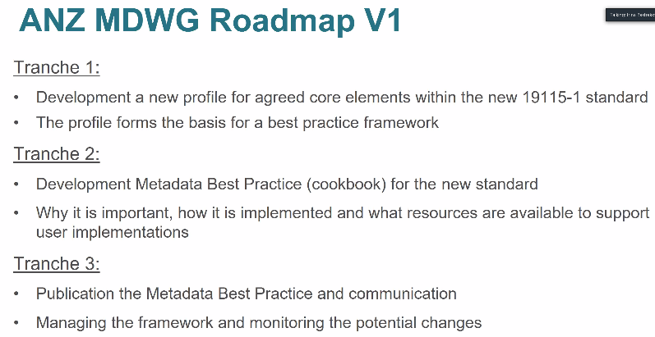  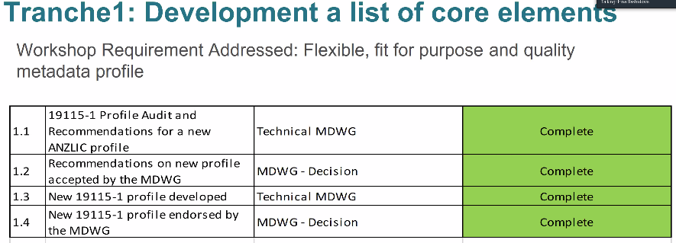  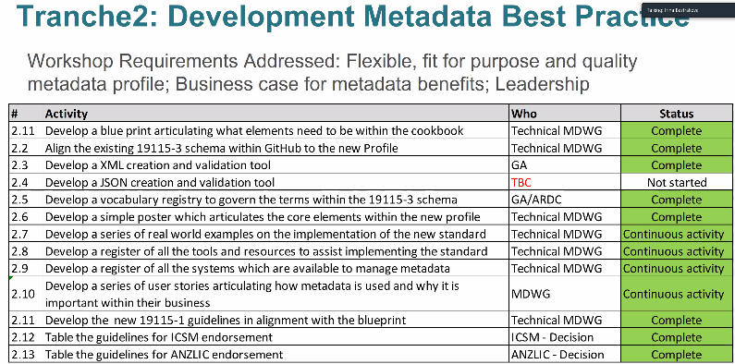  2.4 No specific requirement for JSON tool identified by MDWG participants, and no interest in creation/sponsorship – would like to confirm through workshop today whether there is a need to pursue this item  2.7 Identified need to prioritise which examples are required to concentrate on  2.8 MDWG members were encouraged to look at the Tools and Resources Registry and identify missing items  2.9 Register of Metadata Management Systems, which is more targeted for users of the metadata community. A number of resources have been added and MDWG members were encouraged to review and provide feedback regarding further items which should be included  2.10 Continuous activity through face-to-face MDWG meetings by presenting different examples of implementations and updates on activities happening within MDWG. Currently published as a series of presentations associated with MDWG meetings; need to define in new roadmap whether a different publishing format is required  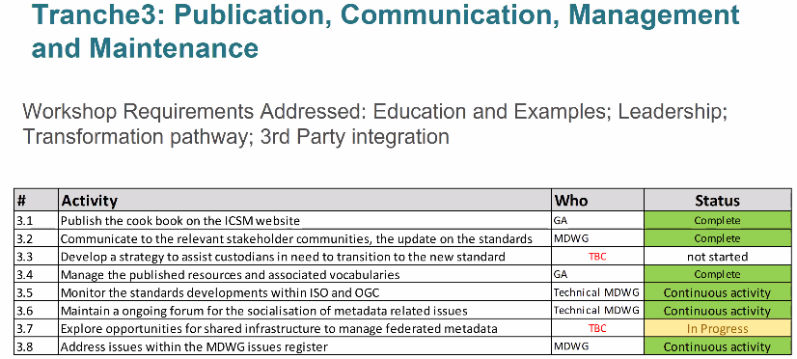  3.3 Has not commenced due to focus on developing profile and other materials; need to transfer activity to new roadmap and consider what strategy required in this context  3.7 Full requirement needs to be identified. Also review concepts such as whether an existing open source tool such as GeoNetwork could be recommended for use as a valid replacement for ANZMet Lite tool (very good support base, global community, updated in line with the standard)  In discussion it was noted that with the MDWG’s maturity and current momentum it is now time to champion and lead, leveraging off memberships of bodies such as OGC to influence development of standards on behalf of the ICSM/ANZLIC communities around interoperability requirements and practical implementation of standards. In order to do this it will be useful to map out relationships within the group to relevant international bodies. It was agreed that Chris, Byron and Simon were to start to develop a document, and that Melanie/Ming look into list of groups held by ARDC if appropriate.  When considering proposed workshop outcomes it was agreed to:  - review action items outstanding in v1 in discussion as part of meeting #6, and  - conduct a survey of agency requirements to gauge current issues which need to be addressed in v2. A compilation of responses will be presented back to the group at a later date.  See action items link for actions agreed above.
ANZLIC/ICSM MDWG Roadmap v2 activities | It was agreed to conduct a survey to identify issues and requirements; and their priorities to form the ANZLIC/ICSM MDWG Roadmap v2
ADMINISTRATION
Next Meeting (Irina Bastrakova) | The next meeting of the MDWG was also discussed following an invitation to host from Brisbane 30-31 July. At this stage it is not possible to know whether travel restrictions will be lifted by this time, or whether ZOOM facilities would be required again. If it is not possible to meet face-to-face it was requested that the agenda be adjusted for shorter days and longer breaks.  In addition, Irina requested overall feedback on the experience of conducting MDWG meetings via ZOOM - timing, facilities, etc.

